Jewish Hospital
Name:
Institution:
Date:

Introduction
Jewish hospital, Louisville is a healthcare facility opened in 1905 to provide high-quality health services to all the patients with intensive research. It is a high-tech developed hospital with national ranking clinical programs. Jewish hospital performs five solid transplants – pancreases, the lungs, heart, kidney, and liver. It is mostly known for the first four hand transplants in the country. Other than the organs transplants, the hospital also provides other special services. It has a capacity of four hundred and sixty-two (462) beds and is a national referral hospital. The research unit of the hospital and the use of technology in most of their services make it an advanced hospital and highly reliable to operate and serious cases. It provides more services to the community around such as healthcare services, physical exercises programs, healthcare classes and frequent events that involve the local community surrounding the hospital. This paper looks at the data needs, requirements and data EER model of the hospital. It also briefly looks at the business model of the hospital.
The business
Business mission: The mission of the Jewish hospital is to provide high-quality healthcare to all its patients with a high and strong emphasis on research and education. The hospital is committed to doing extensive research to come up with the best method and means of providing healthcare. Quality and satisfaction of their customers is an aspect they consider while serving all the patients (Ashley, 2018).
Infrastructure and structures: Jewish hospital is a high-tech company that provides many services under one roof. The hospital has a bed capacity of 462, has organ transplant facilities, cancer center, provides therapy sessions and a class section. The structures are made in such a way to accommodate their patients safely and comfortably. Being a leading research unit for the health care sector in the country, the hospital has a research unit within its facilities.
Information system: The hospital prides itself as a high-tech company with digital records of all its patients, doctors, nurses, medicines, etc. The company has a patient’s portal, a website that allows patients to select doctors, physicians, etc. They are among the hospitals that use electronic medical records.
Products and services: Jewish hospital has many physicians, doctors, nurses, and other medical officers. They offer services such as cancer screening and treatment, diabetes care, organs transplants, emergency services, Loss of weight surgery, neurology, vascular, and orthopedic care, ambulances, and laboratory services. They are a complete hospital, fully equipped to offer all the basic hospital services and the advanced services that require critical care.
Culture: The culture of the hospital is based on the mission of the hospital to provide high-quality medical services to all the patients. The employees in the hospital are highly receptive, high quality and are determined to assist the patient. They offer a wide range of services that make it a special hospital too.
Employees: The hospital has a wide range of employees. It has doctors, nurses, clinical officers, neurologists, physicians, and specialized doctors for special treatments. Availability of employees during an emergency, critical attendance of employees during a situation also makes the hospital highly reliable during an emergency.They are highly trained and specially qualified for the medical job making them highly effective for the job.
Organization structure: The hospital has management and operates in forms of departments. Each department and group of employees have a leader who is answerable to the overall management. The leadership is well organized and so does the services they run at the hospital. Every employee in the hospital has his/her own responsibilities they are well aware of and adhere to them in time.
Data needs and requirements
Jewish hospital uses electronic medical records in all its operations. It produces huge loads of data in a day that requires adequate and efficient methods of data management. The hospital has a huge number of data requirements and needs that we’ll discuss under the following points:
Functional features: The hospital gathers loads amounts of data from all its patients in a day. Their medical records are stored electronically at their databases. Data such as age, sex, medical status, past health history, billing addresses, zip codes, contacts, and name are basic details each patient provides to the hospital . Treatment records, dates of admission and discharge are key data also the company keeps in its system. They need the data for treatment purposes, location and any future references.
Data security: Having collected key data for the patients, they must keep it safe from any cyber-attacks. Billing records, any social security numbers, their location, and contacts are the most vulnerable data by cyber attackers. Jewish hospital, therefore, needs data security features within the organization for the safety of the data they collect from their patients. Advancement of data security features would be necessary for data security.
Completeness of the data: For effective patient treatment, complete data on their past treatments, any complications they might have and any new diagnosis are necessary to address all the factors during treatment. A complete data is, therefore, necessary for every patient for effective treatment and surgical processes.
Organization policy: Jewish hospital prides itself as a high-tech and a hospital that provides high-quality healthcare. They are committed to using the latest technologies in all their treatments and surgeries. They collect data on all their treatment procedures and need it for analysis purposes. The analysis is on ways they can improve their treatments and surgeries.
Ease of use: In treatment, the company requires data that can easily be understood to provide the right medication. Data may include the status of the body, age, allergies, etc. that are necessary for treatment purposes. The data needs to be in the easiest forms for it to be effective in the treatment process (Elger, 2018).
Manageability of the data: Being a hospital, data management is not the key responsibility.However, the data they collect must be manageable. Easy to enter, retrieve and analyze.
EER DIAGRAM
Jewish hospital has a high number of patients and employees. EER diagram for the hospital is complex because of the data they collect from the patients, employees and other hospital needs. The hospital is highly digitalized and therefore most of their services are done via a computer system.
There are various relationships in the EER diagram. The primary entities in the data model below are the doctors, patients, rooms, records, treatment, medicines, receptionist, nurses, and other employees. They all relationships that lead to foreign keys. The data they collect or give gives them a relationship. All the primary keys within the ER model are in blue color while the foreign keys are in purple color. In green are the actions between any two primary keys (Kuusniemi, 2016).
The various relationships within the keys are pointed using the arrows within the diagram. There are many related aspects, primary and foreign keys within the Jewish hospital making the EER diagram complex.
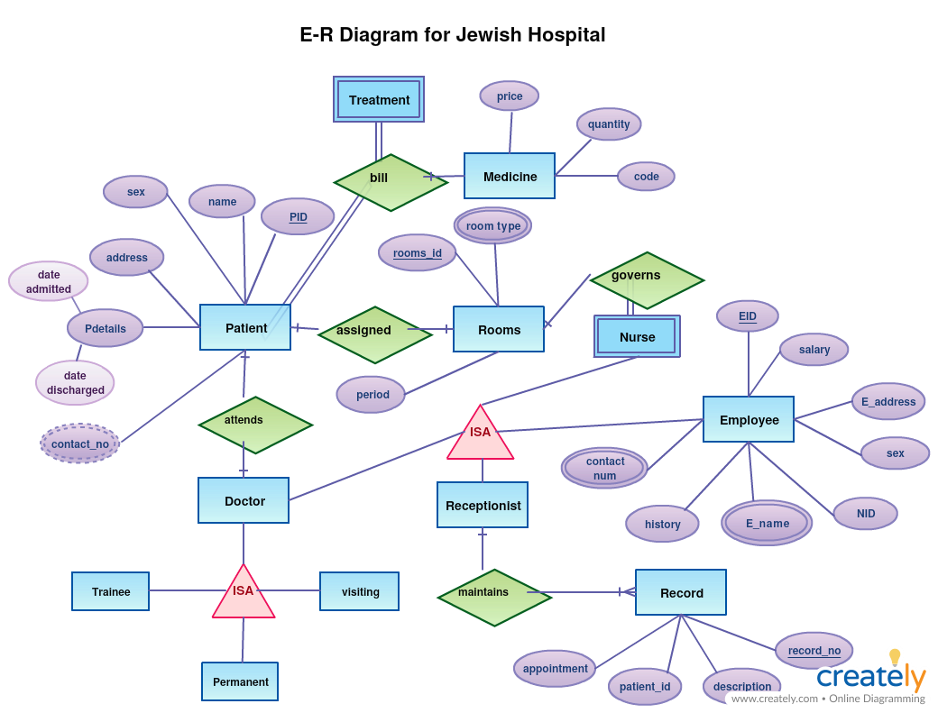
EER diagram for the Jewish hospital
Conclusion
Jewish hospital is an example of how data in a hospital is handled and why it is required. Collection of data is key to any hospital, both from the patients and the employees as it enables them to improve their services and serve better. With data, a company can analyze its weak links and make decisions based on the historical data for improvements. Aside from treatments, Jewish hospital can use the data to analyze how they can make their services even better.

Work cited
Ashley, D. W., Pracht, E. E., Garlow, L. E., Medeiros, R. S., Atkins, E. V., Johns, T. J., ... & Nicholas, J. M. (2018). Evaluation of the Georgia trauma system using the American College of Surgeons Needs-Based Assessment of Trauma Systems tool. Trauma surgery & acute care open, 3(1), e000188.
Dziadzko, M. A., Gajic, O., Pickering, B. W., & Herasevich, V. (2016). Clinical calculators in hospital medicine: Availability, classification, and needs. Computer methods and programs in biomedicine, 133, 1-6.
Jones, J., Nowacki, A. S., Greene, A., Traul, C., & Goldfarb, J. (2017). Investigating parent needs, participation, and psychological distress in the children’s hospital. Hospital Pediatrics, 7(7), 385-394.
Koné, I., Zimmermann, B., Wangmo, T., Richner, S., Weber, M. T., & Elger, B. S. (2018). Hospital discharge of patients with ongoing care needs a cross-sectional study using data from a city hospital under SwissDRG. Swiss medical weekly, 148.
Ritchie, A., & Kuusniemi, M. E. (2016). Developing Research Data Management Practices at a University Hospital Library in Australia–An International Collaborative Project. In Knowledge, Research, Innovation. eHealth 15th EAHIL Conference, 6 - 11.

